**159.334 - Assignment 1  
Checklist**

|  |  |  |  |
| --- | --- | --- | --- |
|  | **Item** | **your assignment details** | |
| 1 | Names and ID numbers of Group Members | Benjamin Upton - 16463710 Jordan Drumm - 17044923  Zane Lamb - 15160640 | |
| 2 | Operating System(s) used for testing your FTP server codes | Windows 10 Pro - 10.0.17134 Ubuntu 18.04.2 LTS | |
| 3 | Compiler used | g++ 8.2.0 | |
| 4 | IDE used | SublimeText 3 | |
| 5 | Required Functionalities | **EPRT** command | full |
| **LIST** command | full |
| **RETR** command | full |
| **TYPE** command | full |
| 6 | Snap shots of sample interactions: one for each required command. | Yes (See below) | |
| 7 | Extra work done (Max Bonus of 3 marks) | Yes. The server is cross platform (will work on both UNIX and Windows Operating systems). Build it using the corresponding makefile (makefileWindows for Windows and Makefile for Linux). Both CWD and PWD commands are implemented. | |

Screenshots of Commands in Use.

USER and PASS  
  
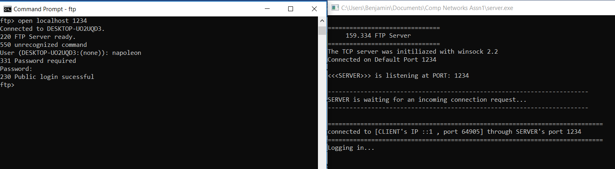

SYST

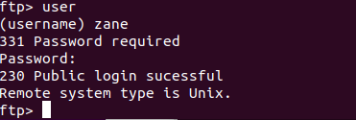

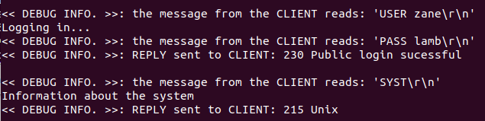

OPTS  
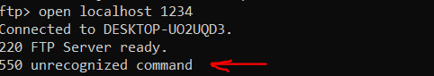

EPRT and LIST  
  
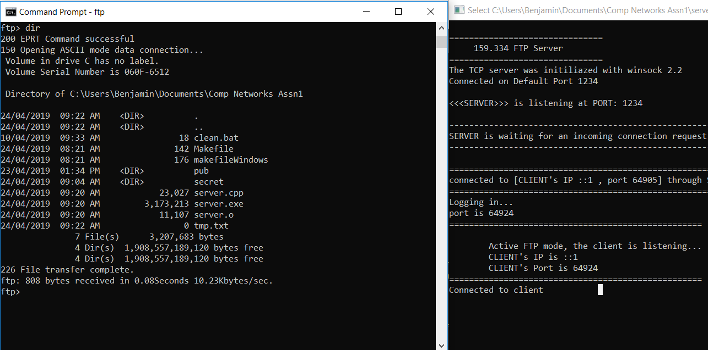

RETR

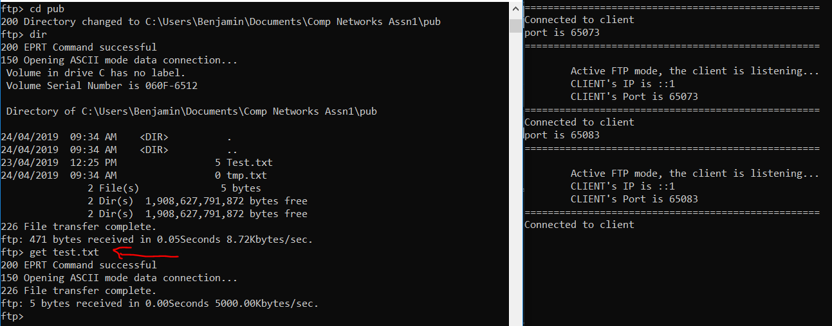

TYPE

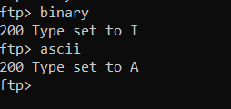

CWD and PWD (including security) and image transfer in binary.

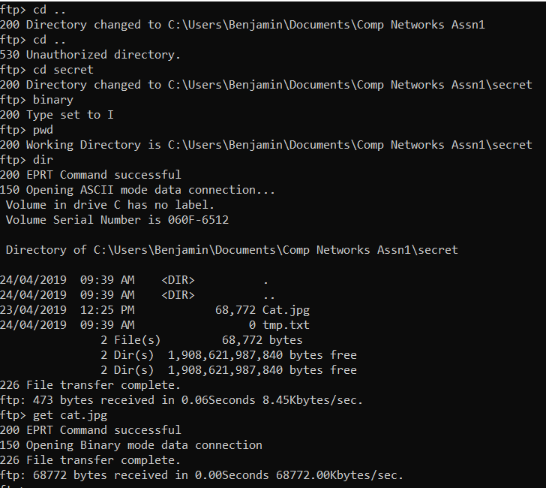

QUIT

